CHAPTER FOUR
SYSTEM IMPLEMENTATION AND EVALUATION
4.1 System implementation
The implementation of ACE, a web based study companion system involved the integration of several core functionalities to create a comprehensive and intelligent learning platform. These functionalities include real-time conversational AI tutoring, automated study planning, document analysis using Optical Character Recognition (OCR), gamification for user engagement, and advanced performance prediction capabilities. The system was built using a modular architecture that combines a Flask backend with a React frontend, supported by Firebase for data management and XGBoost for predictive analytics.
The backbone of the application is built on Flask, a lightweight Python web framework known for its flexibility and ability to support event-driven architectures. Flask manages the complex backend logic, including the routing of API requests, the processing of uploaded documents, and the orchestration of the Machine Learning pipeline. This pipeline integrates an XGBoost classification model that achieves 94.4% accuracy in predicting student success probabilities, allowing the system to identify at-risk students proactively.
Firebase, a popular platform that offers various backend service, was selected because it offers both authetication and database management services as a single system. this makes integration of the system seamless and removes any complex setup for user authentication systems and database servers. Firestore a NoSQL database offers real-time syncing, easy scalability and schema-less design this is suited for the dynamic nature of the system and ideal for real-time learning updates. Firestore supports JSON-like documents and easy retrieval of data objects, such has user profiles, chat session histories, video recommendation URLs, and quiz scores.
By integrating Flask for robust backend logic, Firebase for scalable real-time data management, and React for an interactive user interface, the system achieved a secure, responsive, and highly scalable environment capable of supporting real-time learning updates and personalized student feedback.
4.2 Testing of the Application
The Study Companion system went through comprehensive testing strategies to ensure that the system works has intended and meets all expected requirements. Two important types of testing were carried out, known as alpha and beta testing. These tests were conducted to ensure the reliability, accuracy, and usability across all system modules so that it would be ready to be launched.
4.2.1 Alpha Testing
Alpha testing was conducted internally by the development team to verify the correctness of the code and the integration of various modules. This phase utilized "White Box" testing techniques, focusing on the internal logic of the Flask routes and service functions.
- Unit Testing: Individual components, such as the verify_token_from_request function in helpers.py and the KeyManager class in key_manager.py, were tested to ensure they handled valid and invalid inputs correctly.
- API Endpoint Testing: Tools like Postman were used to simulate HTTP requests to endpoints such as /register, /chat, and /predict_performance. This verified that the JSON responses matched the expected schema and that appropriate HTTP status codes (e.g., 200 OK, 400 Bad Request) were returned.
- Integration Testing: The interaction between the Flask backend and external components was tested to ensure robust system performance. Specific validation areas included:
- Firebase: Ensured accurate user profile creation, secure authentication, and real-time database updates.
- Cloudinary: Confirmed successful upload and retrieval of study materials with a >99% success rate.
- Text-to-Speech: Validated the clarity and speed of audio responses using the Google Generative AI "Charon" voice.
4.2.1 Beta Testing
Beta testing involved releasing the application to a limited group of final-year Computer Science students to evaluate the system in a real-world environment.
- Usability Testing: Users interacted with the "Felix" chatbot and the "Study Plan" generator to assess the intuitiveness of the interface.
- Load Testing: The system's responsiveness was monitored when multiple users generated quizzes or requested audio summaries simultaneously, testing the efficiency of the generate_audio_with_retry service and the API key rotation logic.

4.3 Hardware requirement
The study companion system is designed operate in cloud environments, the system minimizes the reliance on physical hardware for backend. However, specific hardware considerations apply to both deployment and client access:

4.3.1 Server-Side Hardware Requirements
Component | Specification
Processor | Minimum: 2 vCPU cores (Intel Xeon or equivalent) Recommended: 4 vCPU cores for production workloads
RAM | Minimum: 4GB RAM Recommended: 8GB RAM for handling concurrent ML inference and API requests
Storage | Minimum: 20GB SSD storage Recommended: 50GB SSD for logs, temporary files, and model artifacts
Network | Stable internet connection with minimum 100 Mbps bandwidth for API communications and file uploads

4.3.2 Client-Side Hardware Requirements
Component | Specification
Processor | Any modern processor (Intel Core i3 or equivalent, mobile processors acceptable)
RAM | Minimum 2GB RAM for web browser operation

4.4 Software Requirements
The ACE study companion system requires specific software components for both development and production deployment.

4.4.1 Server-Side Software Requirements
Software | Version | Purpose
Operating System | Ubuntu 24.04 LTS | Server operating system
Python | 3.10+ | Core programming language
Flask | 3.1.2 | Web framework for API endpoints
Docker | Latest | Containerization platform
Gunicorn | 22.0.0 | WSGI HTTP server for production
Tesseract OCR | 4.x | Optical character recognition engine

4.4.2 Key Python Libraries
Library | Version | Purpose
firebase-admin | 7.1.0 | Authentication and Firestore database
google-generativeai | 0.8.5 | Gemini AI integration
openai | 2.3.0 | Groq API integration for audio transcription
cohere | 5.18.0 | Backup AI model
langchain | 0.3.27 | Conversation memory management
xgboost | 2.0.3 | Machine learning classification model
scikit-learn | 1.5.0 | Data preprocessing and model evaluation
cloudinary | 1.44.1 | Cloud file storage and management
PyPDF2 | 3.0.1 | PDF text extraction
python-docx | 1.2.0 | Word document processing
python-pptx | 1.0.2 | PowerPoint file processing

4.4.3 Client-Side Software Requirements
- Web Browser: Modern browser with JavaScript support (Chrome 90+, Firefox 88+, Safari 14+, Edge 90+)
- Operating System: Any OS supporting modern web browsers
- Browser Features: Enabled cookies, JavaScript, local Storage, and microphone access permissions (for voice features)

4.4.4 Third-Party Services
Service | Purpose
Firebase Authentication | User authentication and identity management
Google Cloud Firestore | NoSQL database for user profiles, chat history, and activity logs
Google Gemini API | Primary AI model for conversational responses, quiz generation, and content summarization
Groq API | Whisper v3 model for speech-to-text audio transcription
Cohere API | Backup AI model for response generation during API failures
YouTube Data API v3 | Video content recommendations based on user courses and subjects
Render | Cloud deployment platform with Docker support
Cloudinary | Cloud storage for uploaded documents (PDF, DOCX, PPTX, images)
Serper API | Web search integration for supplementary learning resources

4.5 System Security and Protection
Security implementation in the ACE Bot system encompasses multiple layers of protection to safeguard user data, ensure privacy, and prevent unauthorized access.

4.5.1 Authentication and Authorization
- Firebase Authentication: Secure user authentication implemented using Firebase ID tokens with JWT (JSON Web Token) verification for all API endpoints.
- Token-Based Access Control: Every protected route validates bearer tokens through the verify_token_from_request() helper function, ensuring only authenticated users access their data.
- User ID Verification: All database operations are scoped to the authenticated user's UID, preventing cross-user data access.
- Session Management: Chat sessions and user activities are linked to verified user identities, with automatic expiration of inactive sessions.

4.5.2 Data Protection
- Encrypted Data Transmission: All communications between client and server use HTTPS protocol with TLS 1.2+ encryption.
- Environment Variable Protection: Sensitive credentials (API keys, database credentials, JWT secrets) are stored as environment variables and never committed to version control.
- Firestore Security Rules: Database access rules restrict read/write operations to authenticated users and their own documents only.
- Input Sanitization: All user inputs are validated and sanitized through the safe_clean_dict() utility to prevent injection attacks and malformed data.
- File Upload Validation: Uploaded files are verified for type and size limits before processing to prevent malicious uploads.

4.5.3 API Security
- CORS Configuration: Cross-Origin Resource Sharing is enabled with controlled origin policies to prevent unauthorized domain access.
- Rate Limiting: Implicit rate limiting through Firebase and cloud provider quotas prevents abuse and ensures fair usage.
- API Key Rotation: The KeyManager class implements automatic rotation across multiple API keys to prevent service disruption and distribute load.
- Error Handling: Comprehensive error handling prevents information leakage through detailed error messages; generic messages are returned to clients while detailed logs are maintained server-side.

4.5.4 Privacy and Compliance
- Data Minimization: Only essential user information is collected and stored to minimize privacy risks and comply with data protection principles.
- Data Retention: User data is retained only as long as necessary for service provision, with automated cleanup of outdated session data.
- User Consent: Clear privacy policies inform users about data collection, usage, and retention practices before account creation.
- Right to Deletion: Users can permanently delete their accounts and associated data through the delete-account endpoint with immediate removal from all storage systems.

4.6 User Training
The ACE study companion system is designed with user-friendliness as a core principle, requiring minimal training for effective utilization. However, comprehensive user guidance is provided through multiple channels to ensure optimal user experience and feature adoption.

4.6.1 Onboarding Process
New users are guided through a structured onboarding workflow designed to familiarize them with core functionalities:
- Account Creation Tutorial: Step-by-step guidance during registration explaining each required field (name, date of birth, course of study, subjects) and how this information personalizes the learning experience.
- Profile Completion: Interactive prompts encourage users to complete their academic profile for accurate performance predictions and tailored study recommendations.
- Feature Tour: First-time users receive an optional interactive tour highlighting key features including chat functionality, document upload, quiz generation, and study planning tools.
- Sample Interactions: Pre-loaded example queries demonstrate the tutor's capabilities in solving mathematical problems, explaining scientific concepts, and generating study materials.

4.6.2 In-App Guidance
- Contextual Help: Tooltips and help icons provide immediate assistance at decision points throughout the interface.
- Error Messages: User-friendly error messages guide users toward resolution when issues occur, avoiding technical jargon.
- Progress Indicators: Visual feedback during file uploads, quiz generation, and document processing keeps users informed of system status.
- Feature Prompts: Contextual suggestions encourage users to explore underutilized features based on their usage patterns.

4.6.3 Documentation and Resources
- User Manual: Comprehensive documentation covering all system features, workflows, and best practices for maximizing learning outcomes.
- FAQ Section: Common questions addressing account management, feature usage, troubleshooting, and privacy concerns.
- Example Use Cases: Documented scenarios demonstrating how students in different disciplines can leverage ACE for exam preparation, homework assistance, and concept review.

The intuitive design philosophy ensures that most users can navigate primary functions without formal training, while comprehensive resources support advanced feature adoption.

4.7 System Maintenance
Continuous system maintenance ensures optimal performance, security, and reliability of the ACE platform. A comprehensive maintenance strategy addresses both preventive and corrective measures.

4.7.1 Preventive Maintenance
Regular preventive activities minimize system downtime and ensure consistent service quality:
- Dependency Updates: Monthly review and update of Python libraries and dependencies to incorporate security patches and performance improvements. Critical security updates are applied immediately upon release.
- Database Optimization: Weekly database maintenance includes index optimization, query performance analysis, and cleanup of orphaned records in Firestore collections.
- Log Rotation: Automated log management with 30-day retention policy prevents disk space exhaustion while maintaining audit trails for debugging and security analysis.
- Cache Management: Periodic clearing of temporary files and session data to maintain optimal system performance.
- Backup Verification: Weekly automated backups of critical data with monthly restoration testing to ensure backup integrity.

4.7.2 Performance Monitoring
- Real-Time Metrics: Continuous monitoring of API response times, error rates, and system resource utilization through Render platform dashboard.
- API Quota Tracking: Monitoring of third-party API usage (Gemini, Groq, Cohere) to prevent service disruptions due to rate limit exhaustion.
- Database Performance: Firestore query performance monitoring with alerts for slow-running queries exceeding 2-second thresholds.
- Storage Utilization: Tracking of Cloudinary storage consumption and bandwidth usage to optimize costs and prevent service interruptions.
- User Activity Patterns: Analysis of peak usage times to inform scaling decisions and resource allocation.

4.7.3 Bug Fixes and Updates
- Issue Tracking: Systematic logging and prioritization of reported bugs using GitHub Issues with classification by severity (critical, high, medium, low).
- Patch Deployment: Critical bug fixes deployed within 24 hours of identification; non-critical fixes bundled in bi-weekly update cycles.
- Regression Testing: Automated test suite execution before each deployment to prevent introduction of new issues.
- Version Control: Git-based version management with tagged releases and detailed changelogs documenting all modifications.
- Rollback Capability: Maintained previous stable versions enable rapid rollback if critical issues emerge post-deployment.

4.7.5 Model Maintenance
- Performance Monitoring: Continuous tracking of ML model accuracy, precision, and recall metrics through automated prediction logging.
- Data Drift Detection: Monthly analysis of input feature distributions to identify concept drift requiring model retraining.
- Model Retraining: Quarterly model updates incorporating new student performance data to maintain prediction accuracy.
- A/B Testing: Comparison of new model versions against production models using holdout sets before deployment.
- Feature Engineering Review: Periodic evaluation of predictive features to identify opportunities for improved accuracy through additional data collection or feature transformation.
Regular maintenance ensures the study companion system remains secure, performant, and aligned with evolving educational technology standards while providing consistent value to student users.

4.8 System Evaluation

The evaluation of the study companion platform was evaluated in two distinct areas: the predictive accuracy of the Machine Learning model and the pedagogical quality of the Generative AI chatbot.

4.8.1 Student Performance Model Evaluation (XGBoost)

The student performance prediction model was trained on a dataset combining study habits and academic performance. The model demonstrated high reliability in identifying students at risk.
  - Accuracy: As shown in Figure 4.8.1.1, the model achieved an accuracy of 94.4% on the test set, indicating a strong ability to correctly classify students as "Pass" or "Fail.".
  - Precision and Recall: For the fail class (0), precision was 96% with 97% recall. For the pass class (1), precision was 82% with 78% recall, indicating reliable identification of at-risk students.
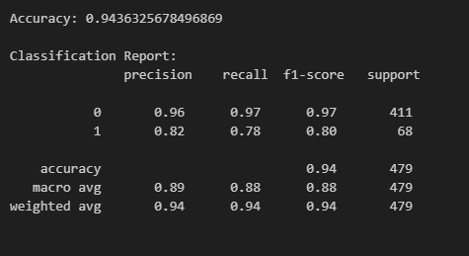
Figure 4.8.1.1 Classification Report
  - Feature Importance: Analysis using the XGBoost feature importance plot (Figure 4.8.1.2) revealed that Study Time Weekly (f0, f1) and Attendance Percentage were the most significant predictors of academic success.
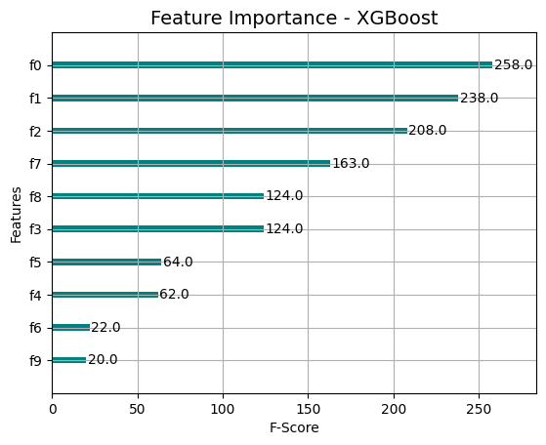
Figure 4.8.1.2 Feature Importance
  - Confusion Matrix: As shown in Figure 4.8.1.3, the model correctly identified 399 students who would fail (True Negatives) and 53 who would pass (True Positives), with very few false positives (12), reducing the risk of giving students a false sense of security.
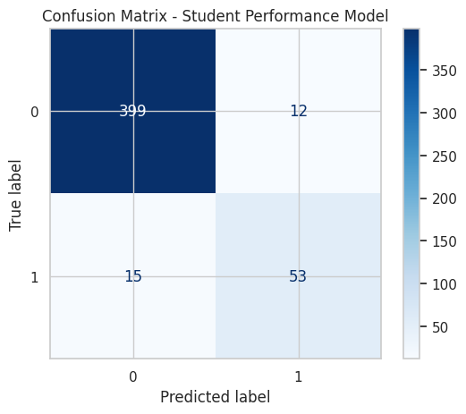
Figure 4.8.1.3 Confusion matrix on Student Performance Model
  - ROC Curve & AUC: As shown in Figure 4.8.1.3, the Receiver Operating Characteristic (ROC) curve yielded an Area Under the Curve (AUC) of 0.88. This demonstrates that the model has a high probability of distinguishing between passing and failing students.
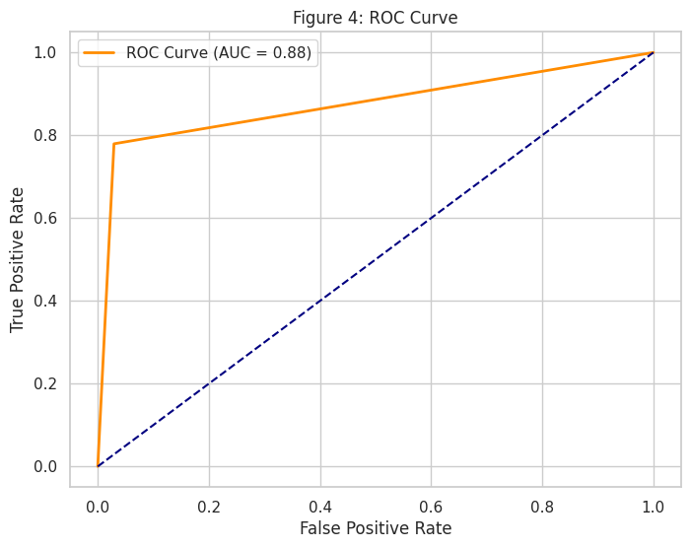
Figure 4.8.1.4 ROC Curve

4.8.2 Generative AI Evaluation (Bloom’s Taxonomy)

The quality of the "Felix" chatbot's responses was evaluated against Bloom’s Taxonomy to ensure it fosters deep learning rather than simple information recall. A sample of chatbot interactions was analyzed and categorized into cognitive levels.
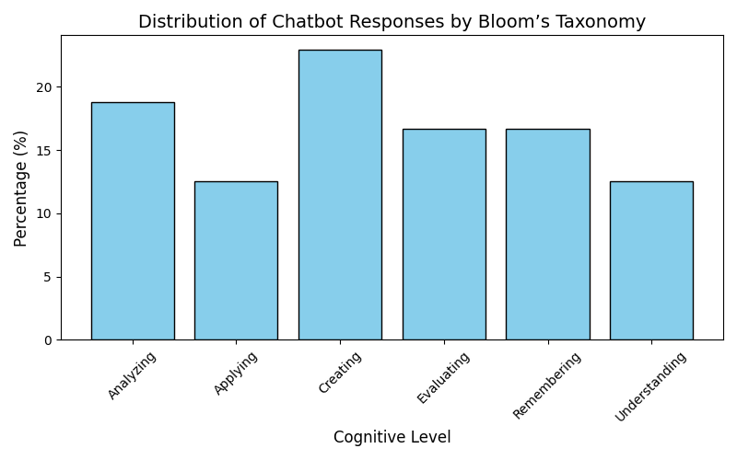
Figure 4.8.2 Bloom Taxonomy on Felix chatbot
Bloom Level | Result For Felix chatbot | Ideal Range | Status
Remembering | 16.7% | 10–20% | Balanced
Understanding | 12.5% | 10–20% | Balanced
Applying | 12.5% | 10–15% | Balanced
Analyzing | 18.8% | 15–20% | Balanced
Evaluating | 16.7% | 10–20% | Balanced
Creating | 22.9% | 15–25% | Balanced

Analysis of Results:
- High-Order Thinking: The system scored highest in the Creating (22.9%) and Analyzing (18.8%) categories. This indicates that the chatbot effectively encourages students to generate new ideas, synthesize information, and break down complex problems, which aligns with the goals of an intelligent tutor.
- Alignment with Ideal Ranges: As illustrated in Figure 4.8.2, the distribution of responses falls strictly within the ideal ranges for an educational tool. This balance ensures that the chatbot does not merely provide definitions (Remembering) but also challenges the user to apply and evaluate concepts.

  - Snapshots of Implementation
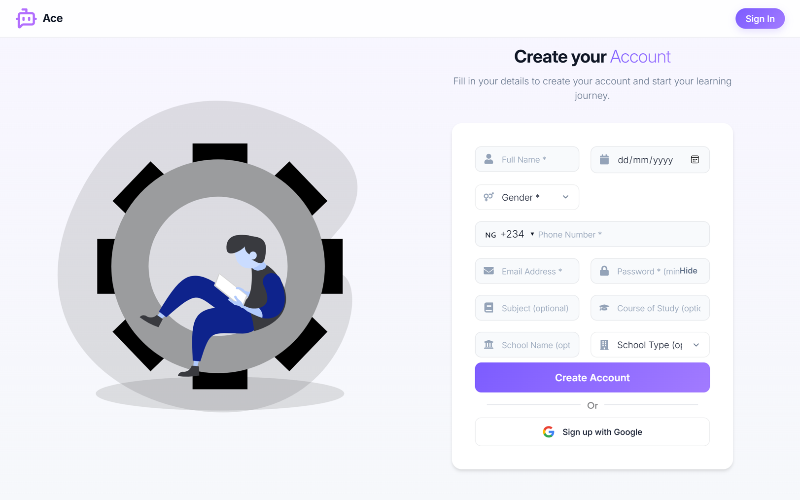
Fig 4.9.1 Register Page

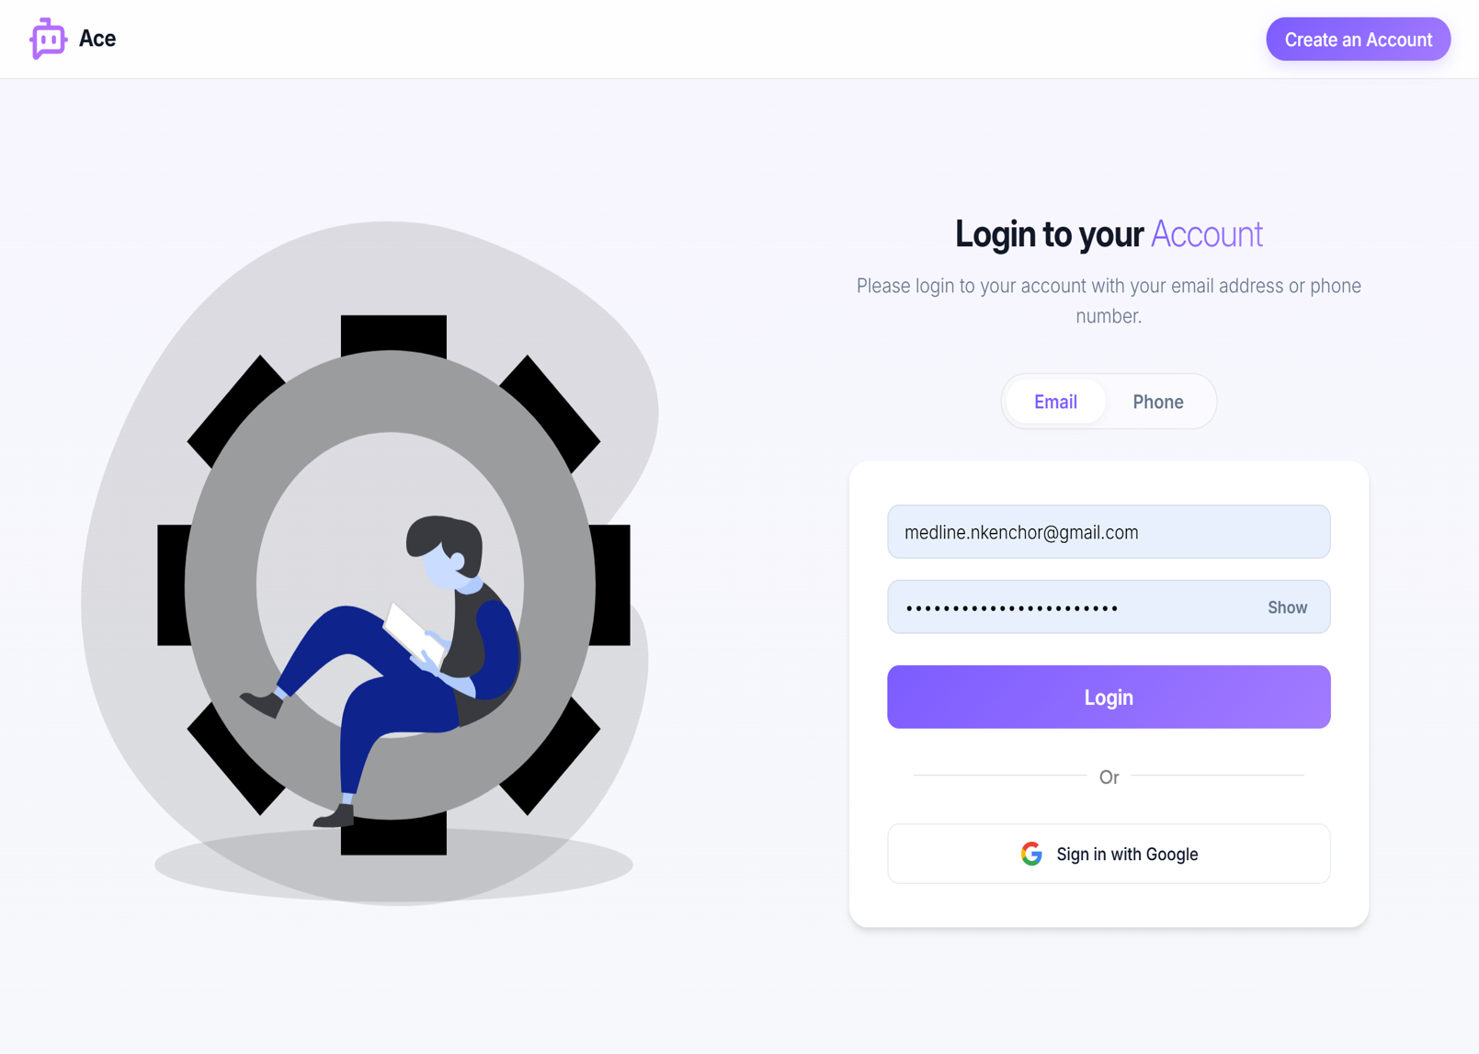

Fig 4.9.2 Login Page

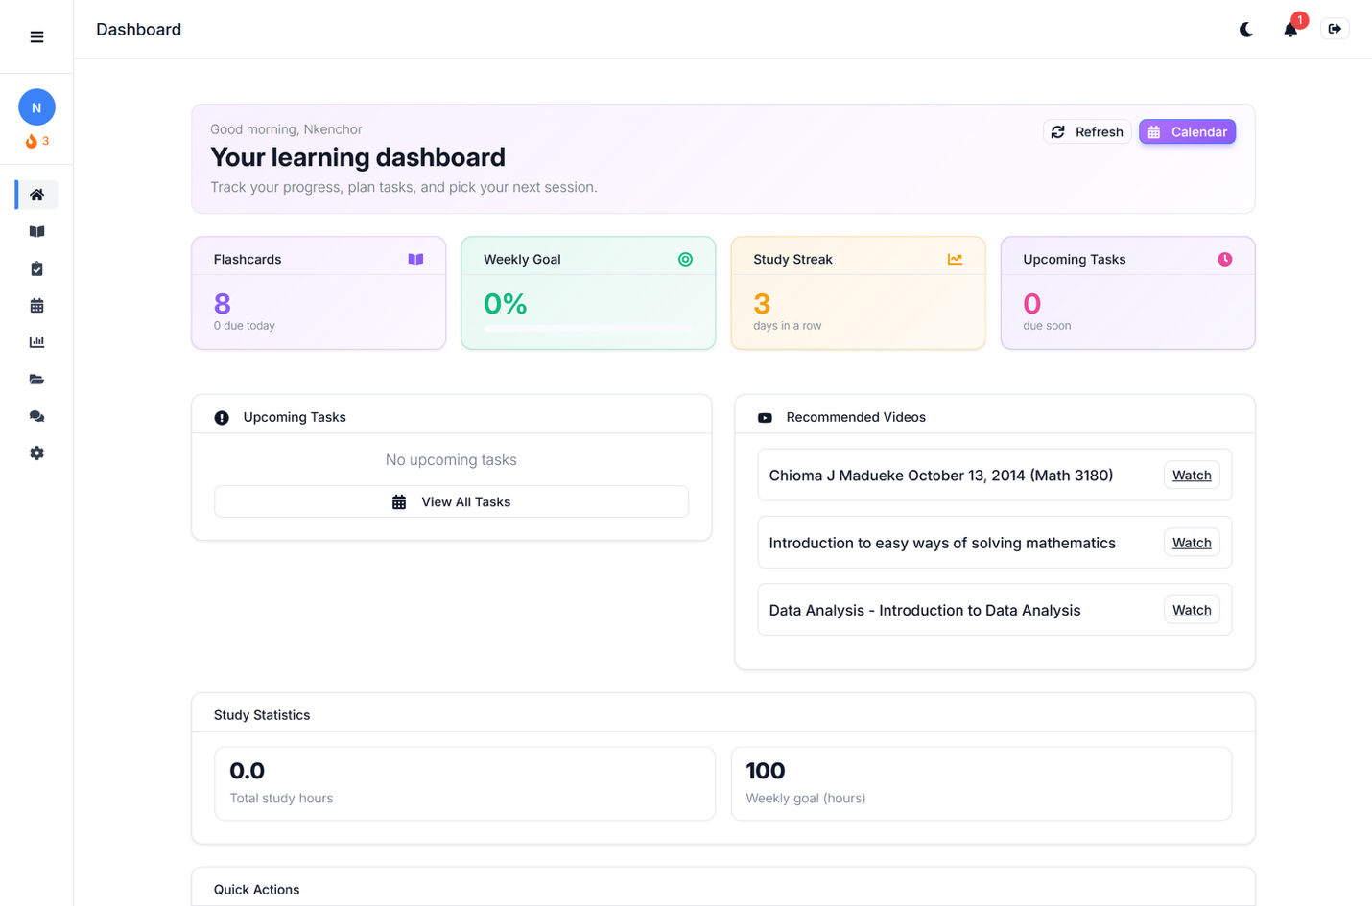
Fig 4.9.3 Learning Dashboard

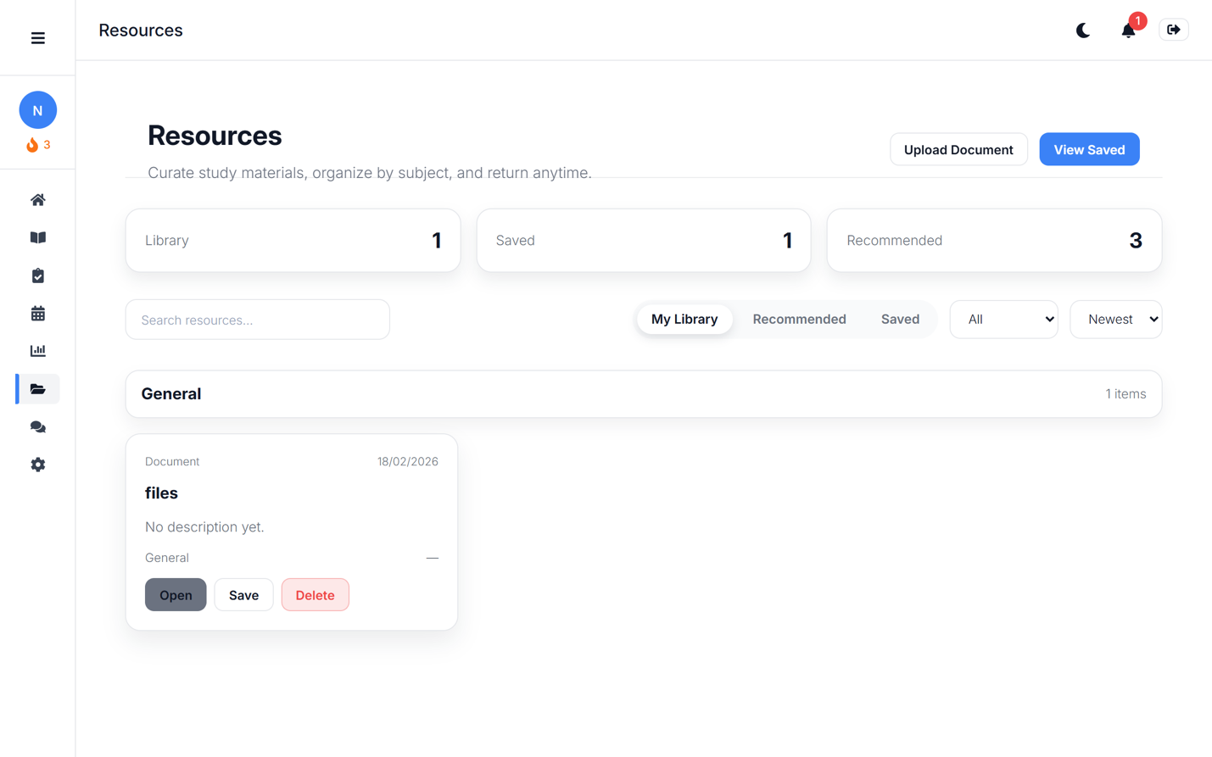
Fig 4.9.4 Resources Page

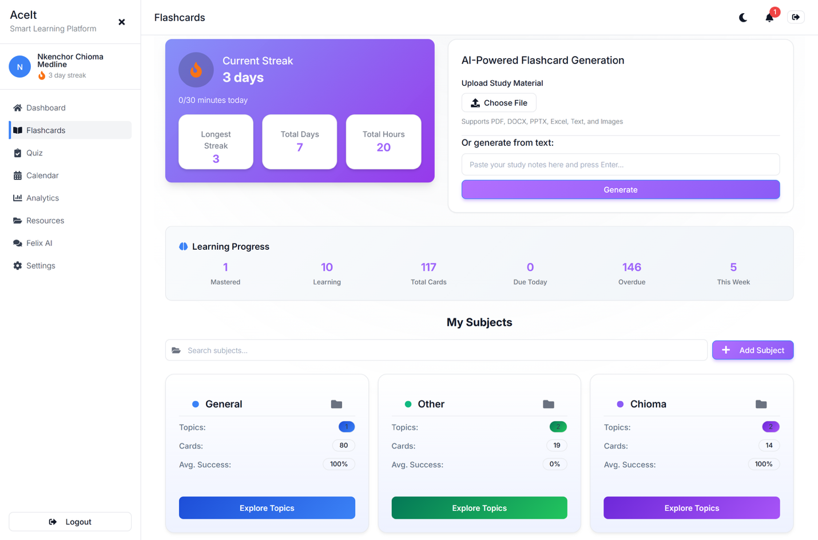

Fig 4.9.5 Flashcards

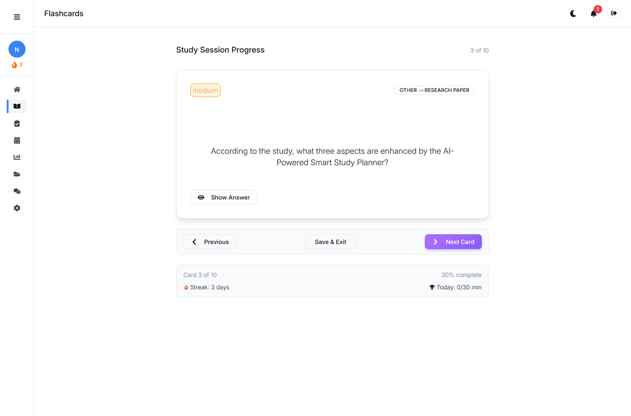
Fig 4.9.6 Flashcard Study Page

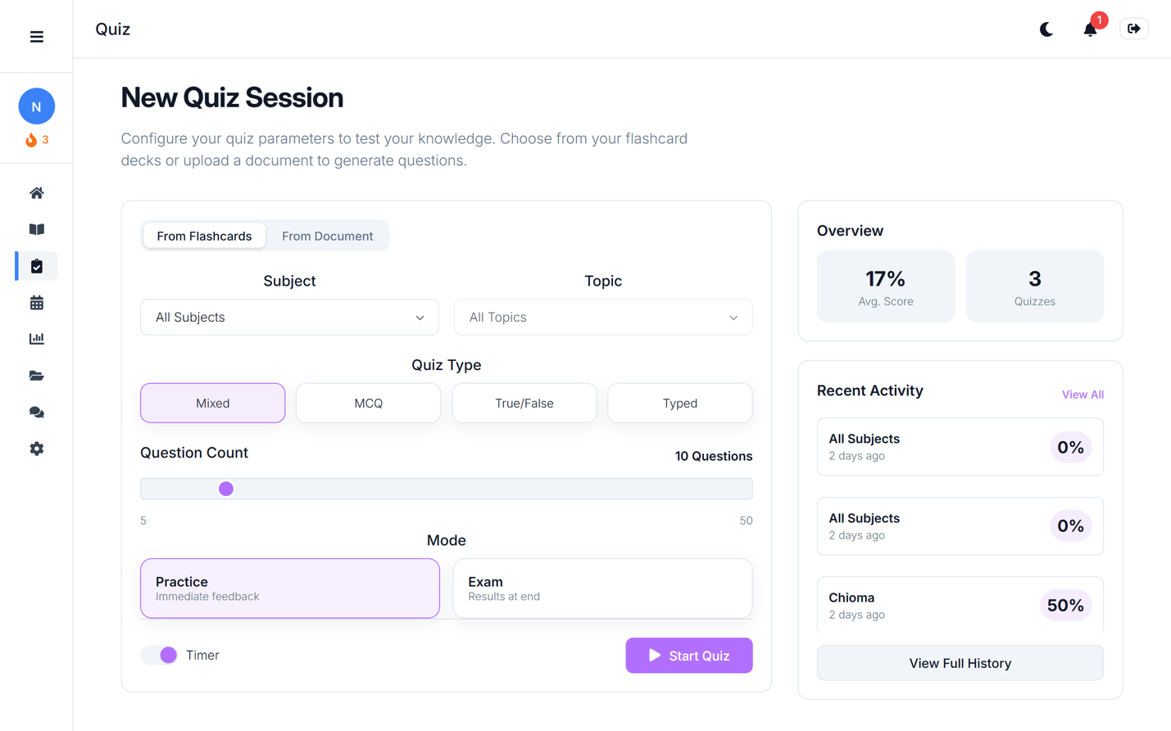
Fig 4.9.7. Quiz Page

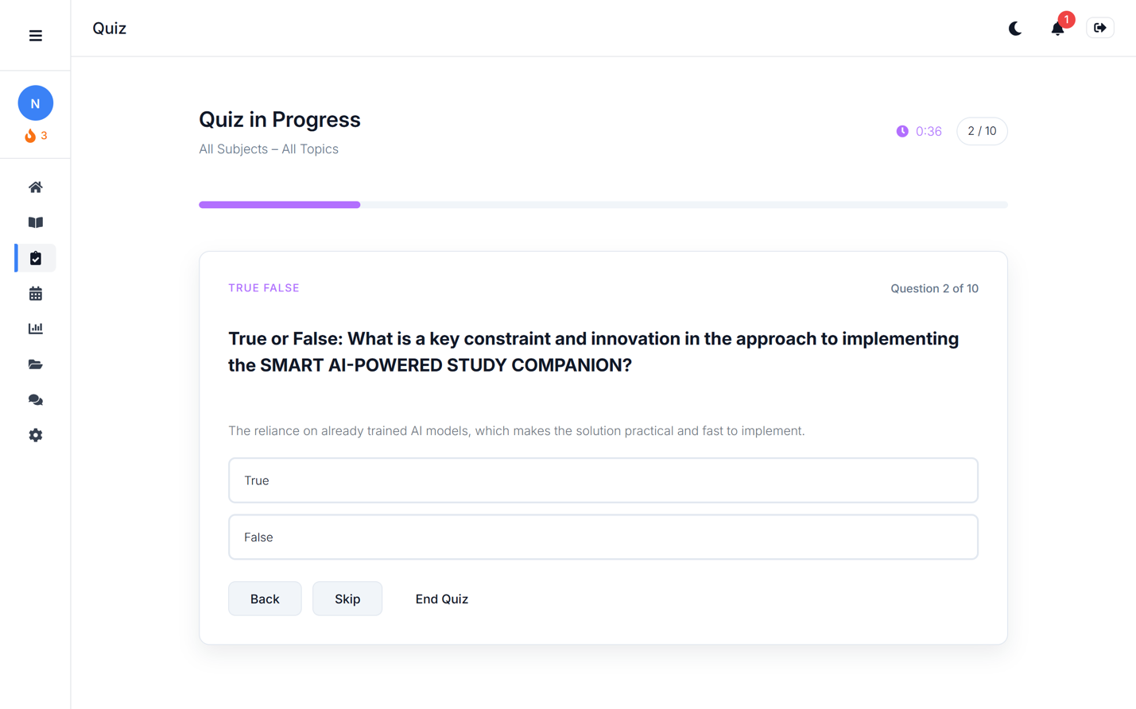
Fig 4.9.8. Quiz In Progress
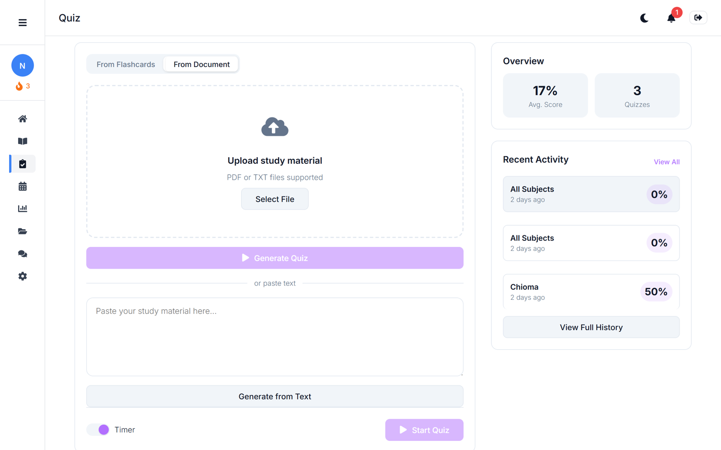
Fig 4.9.10. Quiz Document Upload Page

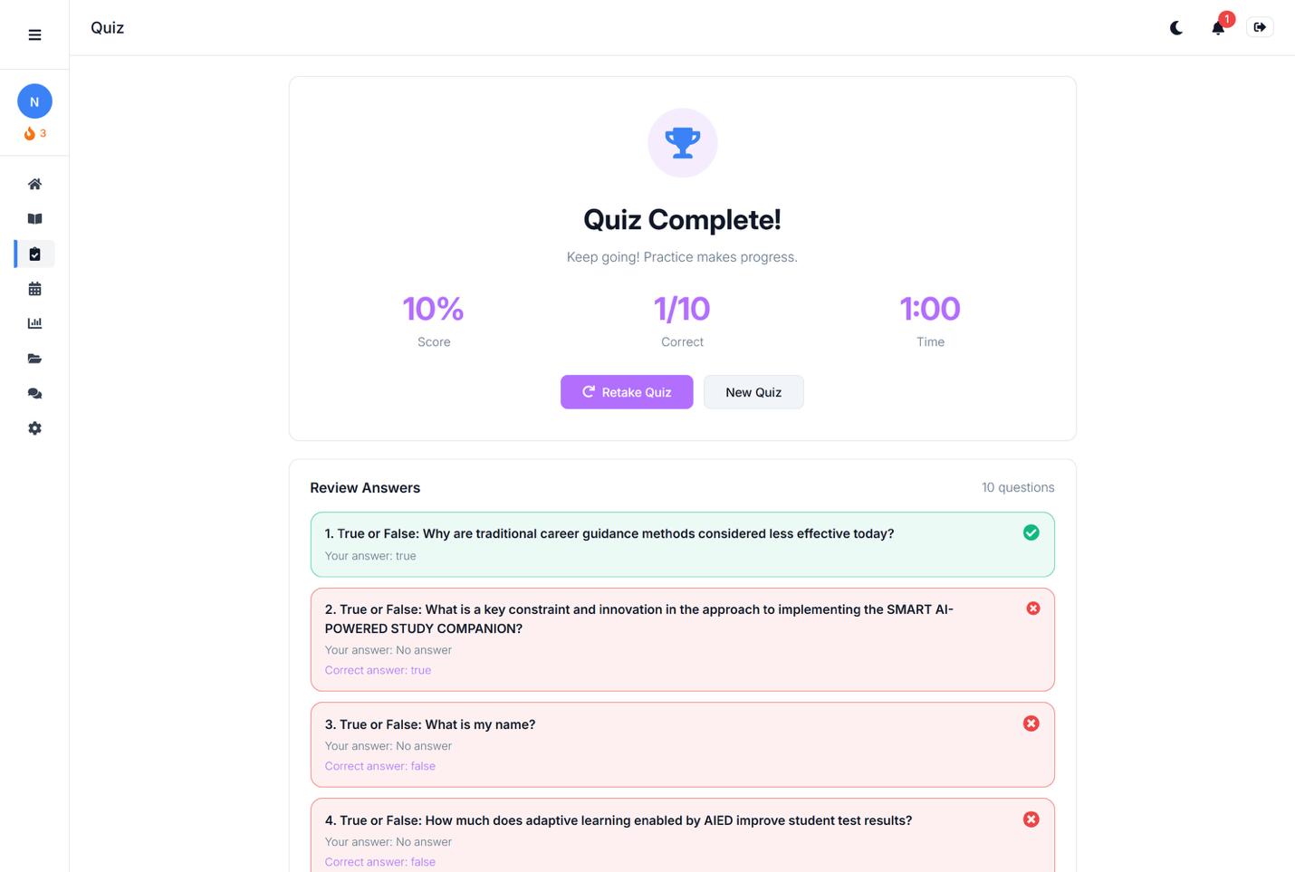
Fig 4.9.11 Quiz Feedback Page
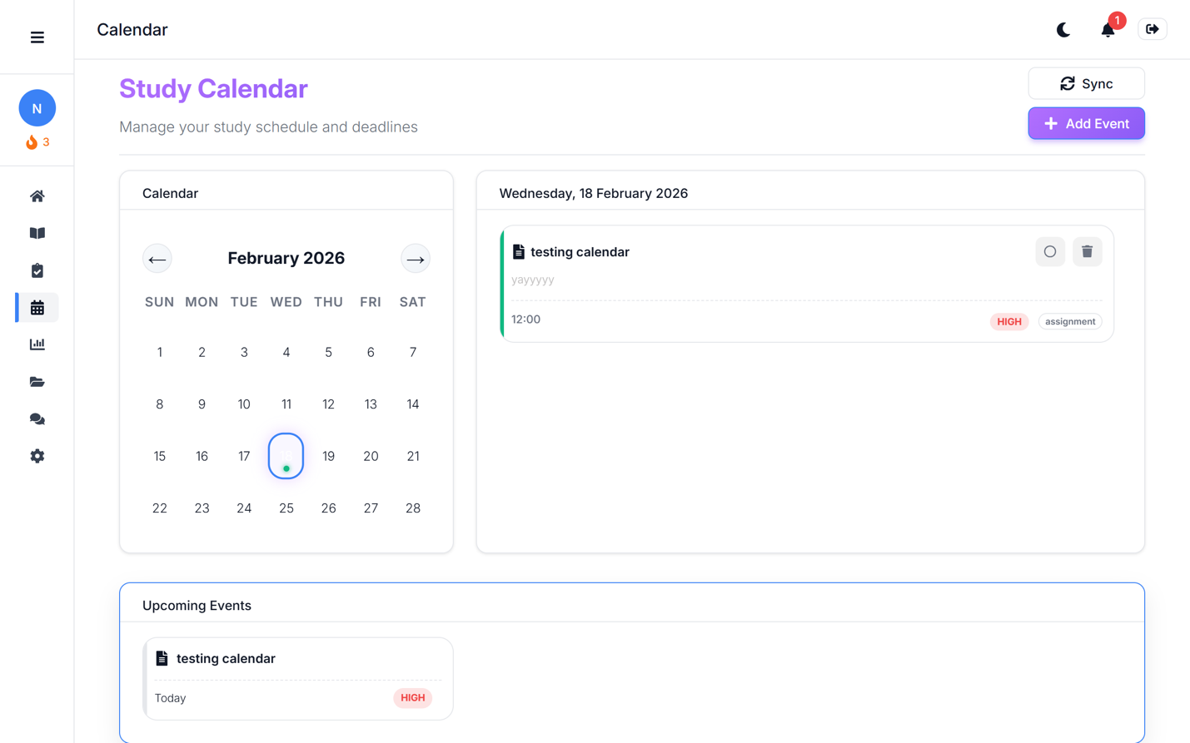
Fig 4.9.12. Calendar Page

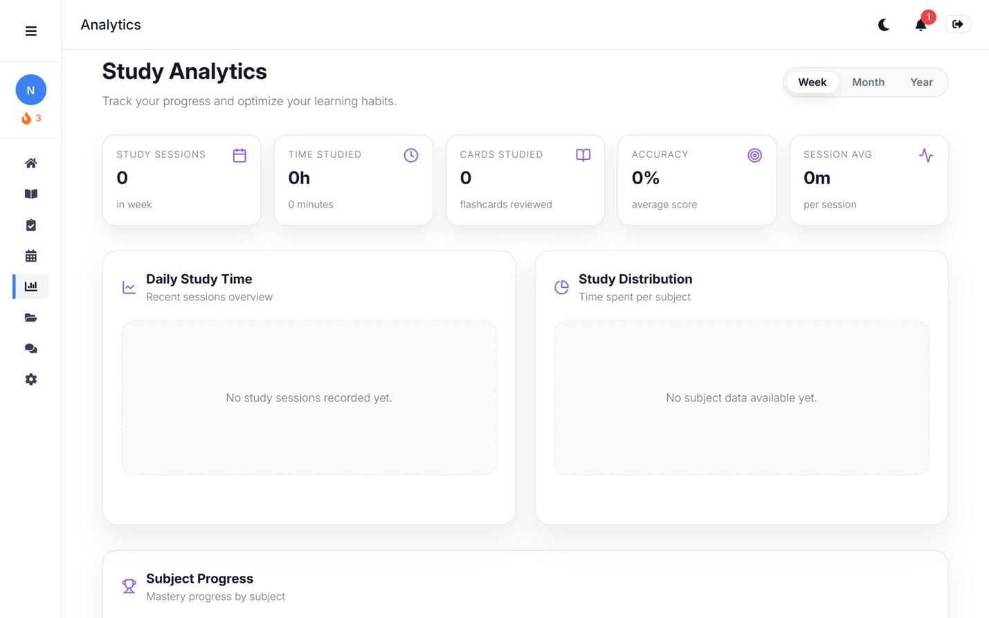
Fig 4.9.13. Study Analytics Page

